The following are key notes to help you with the installation of your new M2/Advance Design coil-over kit. The instructions are not meant in any way to provide full, in-depth installation procedures as it is assumed you have a working knowledge of the 3rd gen RX-7’s suspension underpinnings and how they are put together (or disassembled). Besides, it’s really all common sense. The following documentation should be sufficient to answer any questions you might come across and to aide you with installing the kit in it’s entirety.

1. Adjust all settings to their softest (both bump and rebound). Read the provided material on the adjustment features. You may want to screw the rebound adjuster all the way down and then mark the hole by the yellow indent mark in some way. I used a Dremel to file the edge of the hole. This will serve as a reference point for making future adjustments. See picture below:
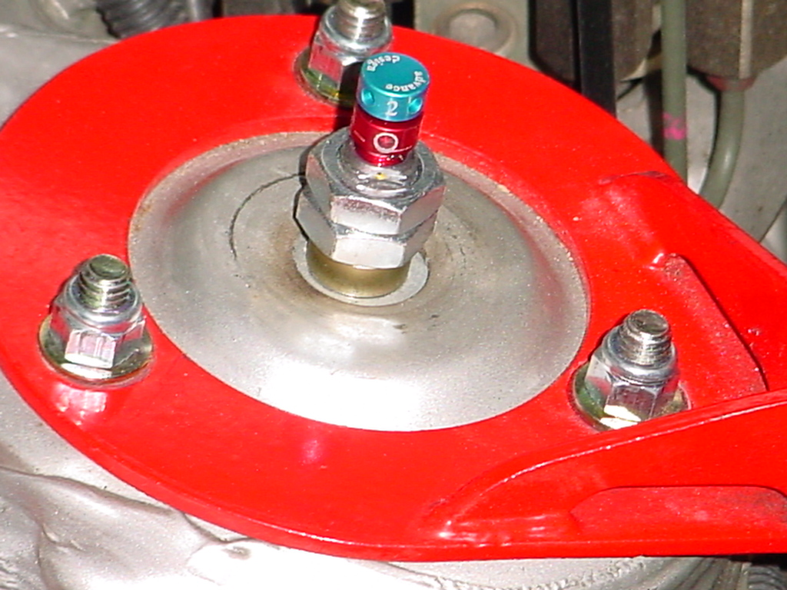

Install just as they come assembled. After you remove your current shocks/springs, adjust the M2/AD to roughly the same height. Do this for the front AND back. If you have a hard time fitting the top of the coil-over assembly up through the holes in the body, simply align the two identical securing nuts so that they are in the same position (better to tighten than to loosen). They should just be able to squeeze through.

1b. The servicing valves near the bottom of the M2/AD shocks should face outward on both the front and rear, when installed. However, if you are running 17”x10” wheels with 275/40 (or wider) on the rear, check your clearance. Some offsets may cause the valve to be too close for comfort. In this case, you may turn the shock around so that the it is on the inner side.

2. The rears are easy. Make sure you have the custom swaybar end links because the stock ones won't work (the threaded extension is too short and too thick – see picture). Insert the supplied bolts from the front to the back, so that the threaded portion is towards the back of the car. The spacer goes on the back before the endlink and nut.
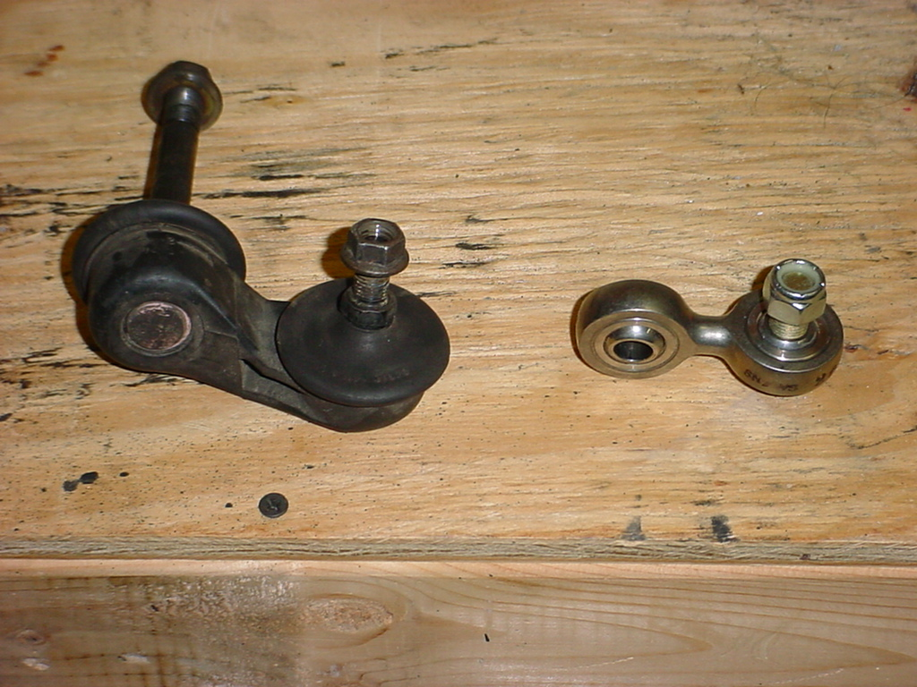

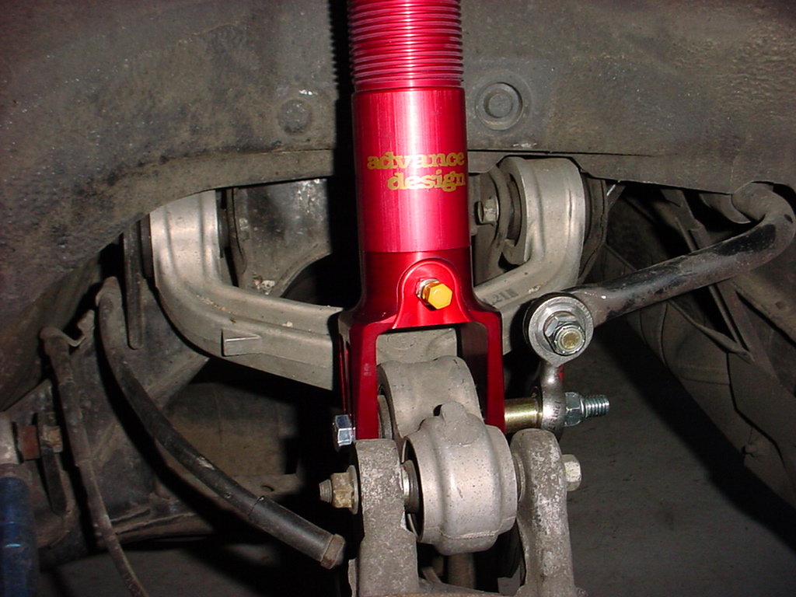
Rear upper mout (from underneath):
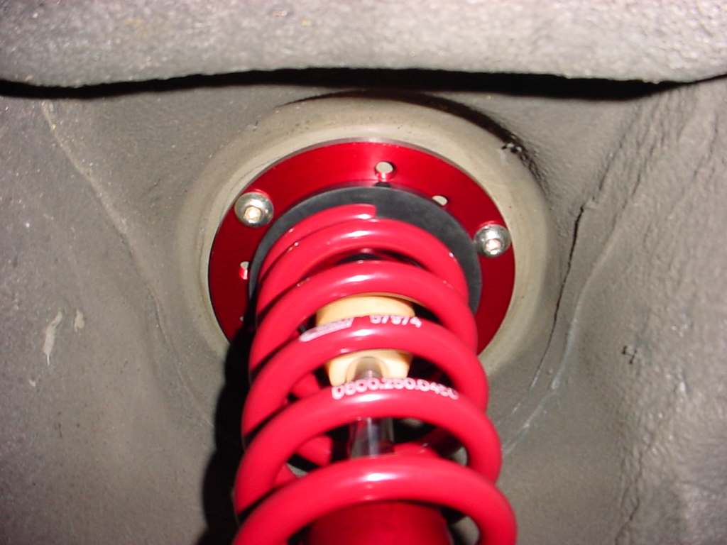

Rear upper mount (from top):
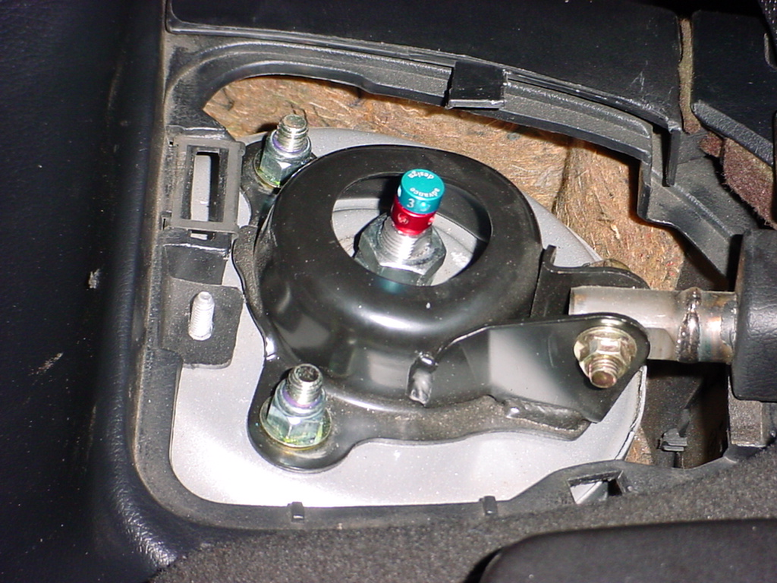
3. The fronts are a little more difficult. The upper A-arm needs to be unbolted from the body to remove/install the coil-overs (any brand). You will also need unbolt the sensor wire bracket. Be careful not to stretch or damage the ABS sensor wire.

3a. Once in place, fully secure the coil-over assembly to the body by tightening the three nuts. The supplied washers go between the nuts and the body (or shock tower brace if you have one).
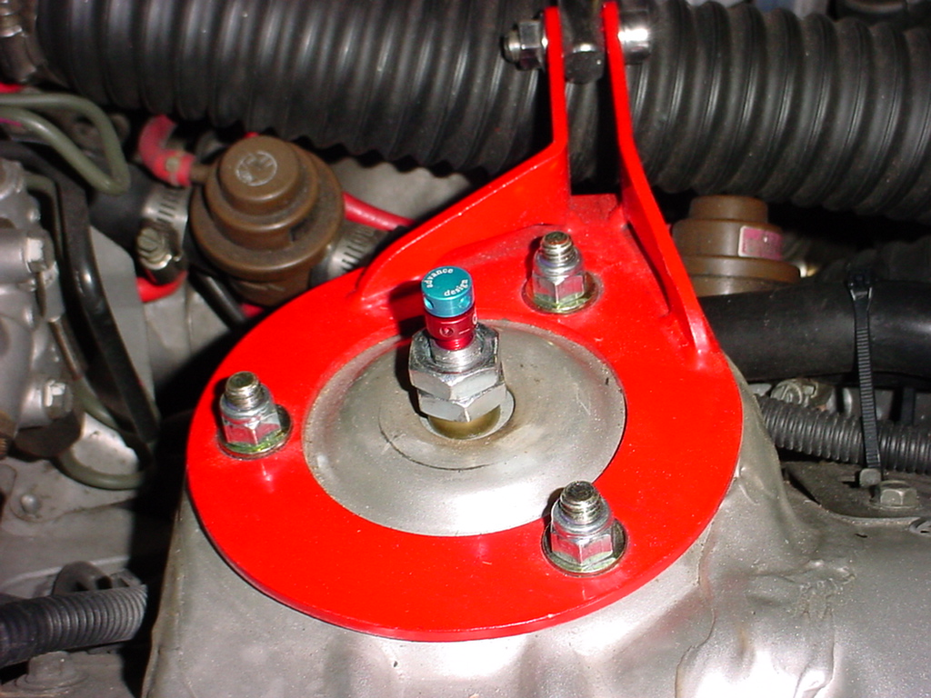

3b. Reattach the upper A-arm, leaving the bolts loose until the coil-over assembly is secured at the bottom. Reattach the ABS sensor wire bracket.
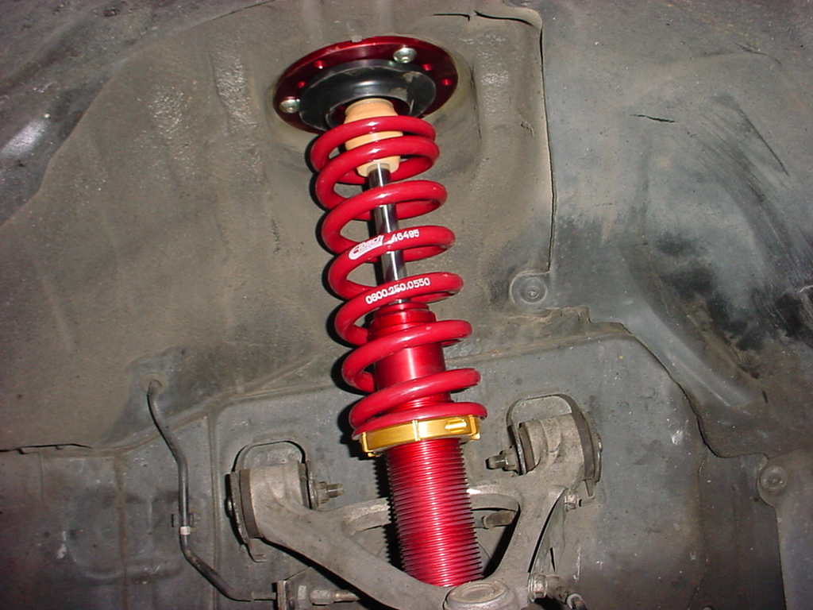

3c. It is tricky to align the bolt shaft in the heim joint (bottom of shock) with the holes in the lower suspension arm. The easiest way to do this is to use two jacks, one on the suspension arm, and another to raise the shock. I piece of wooden dowel (such as a broom handle) can be positioned between the jack and the adjusting ring on the shock. The two need to be raised together until you can align the holes such that the securing bolts can be inserted.

3d. You'll notice a significant amount of gap between the heim-joint bolt shaft and the flanges on the lower suspension arm. This is not a problem. The rear-ward sides of both the left and right lower arms have metal inserts that will get squeezed in when you tighten the nuts. This is why it is important to insert the bolts from the front to back. You may want to use a flat washer (or two) before the nut to fill in some of the extra space. The distance of the heim-joint shaft from end-to-end is 3/16" shorter than the stock shock with bushing (or the Koni Sports for that matter). This makes installation a bit easier, but I'm not sure if the steel inserts being pressed in more will present a problem in the long run. See picture below:
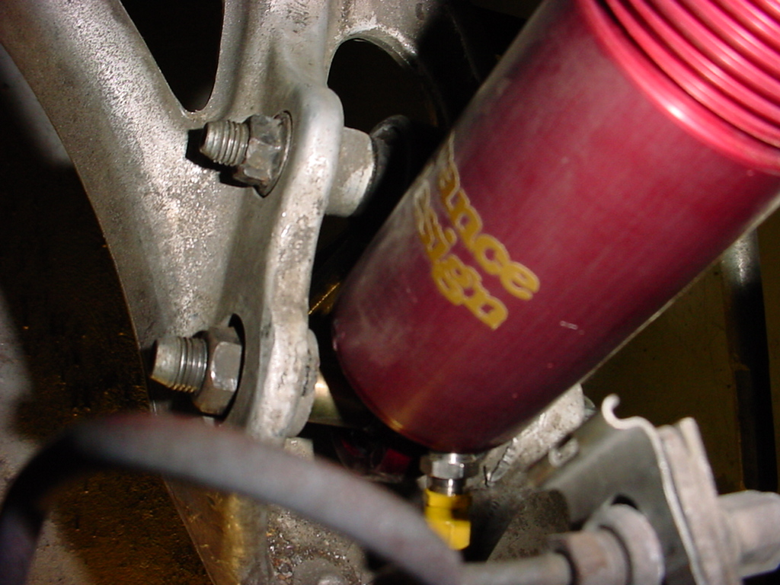

From: Rob Seneker <seneker@bellsouth.net> @ INTL
Date: August 24, 2001

Beautiful work. But regarding the following:

>start>
The rear-ward sides of both the left and right lower arms have metal inserts
that will get squeezed in when you tighten the nuts. This is why it is
important to insert the bolts from the front to back. You may want to use a
flat washer (or two) before the nut to fill in some of the extra space. The
distance of the heim-joint shaft from end-to-end is 3/16" shorter than the
stock shock with bushing (or the Koni Sports for that matter). This makes
installation a bit easier, but I'm not sure if the steel inserts being
pressed in more will present a problem in the long run.
>end>

I propose that if the metal inserts get squeezed inward to much that they
will have insufficient surface area to support the load. Personally, I
think just recommending the use of the washers would be better.

Just my 2 cents.
Rob

